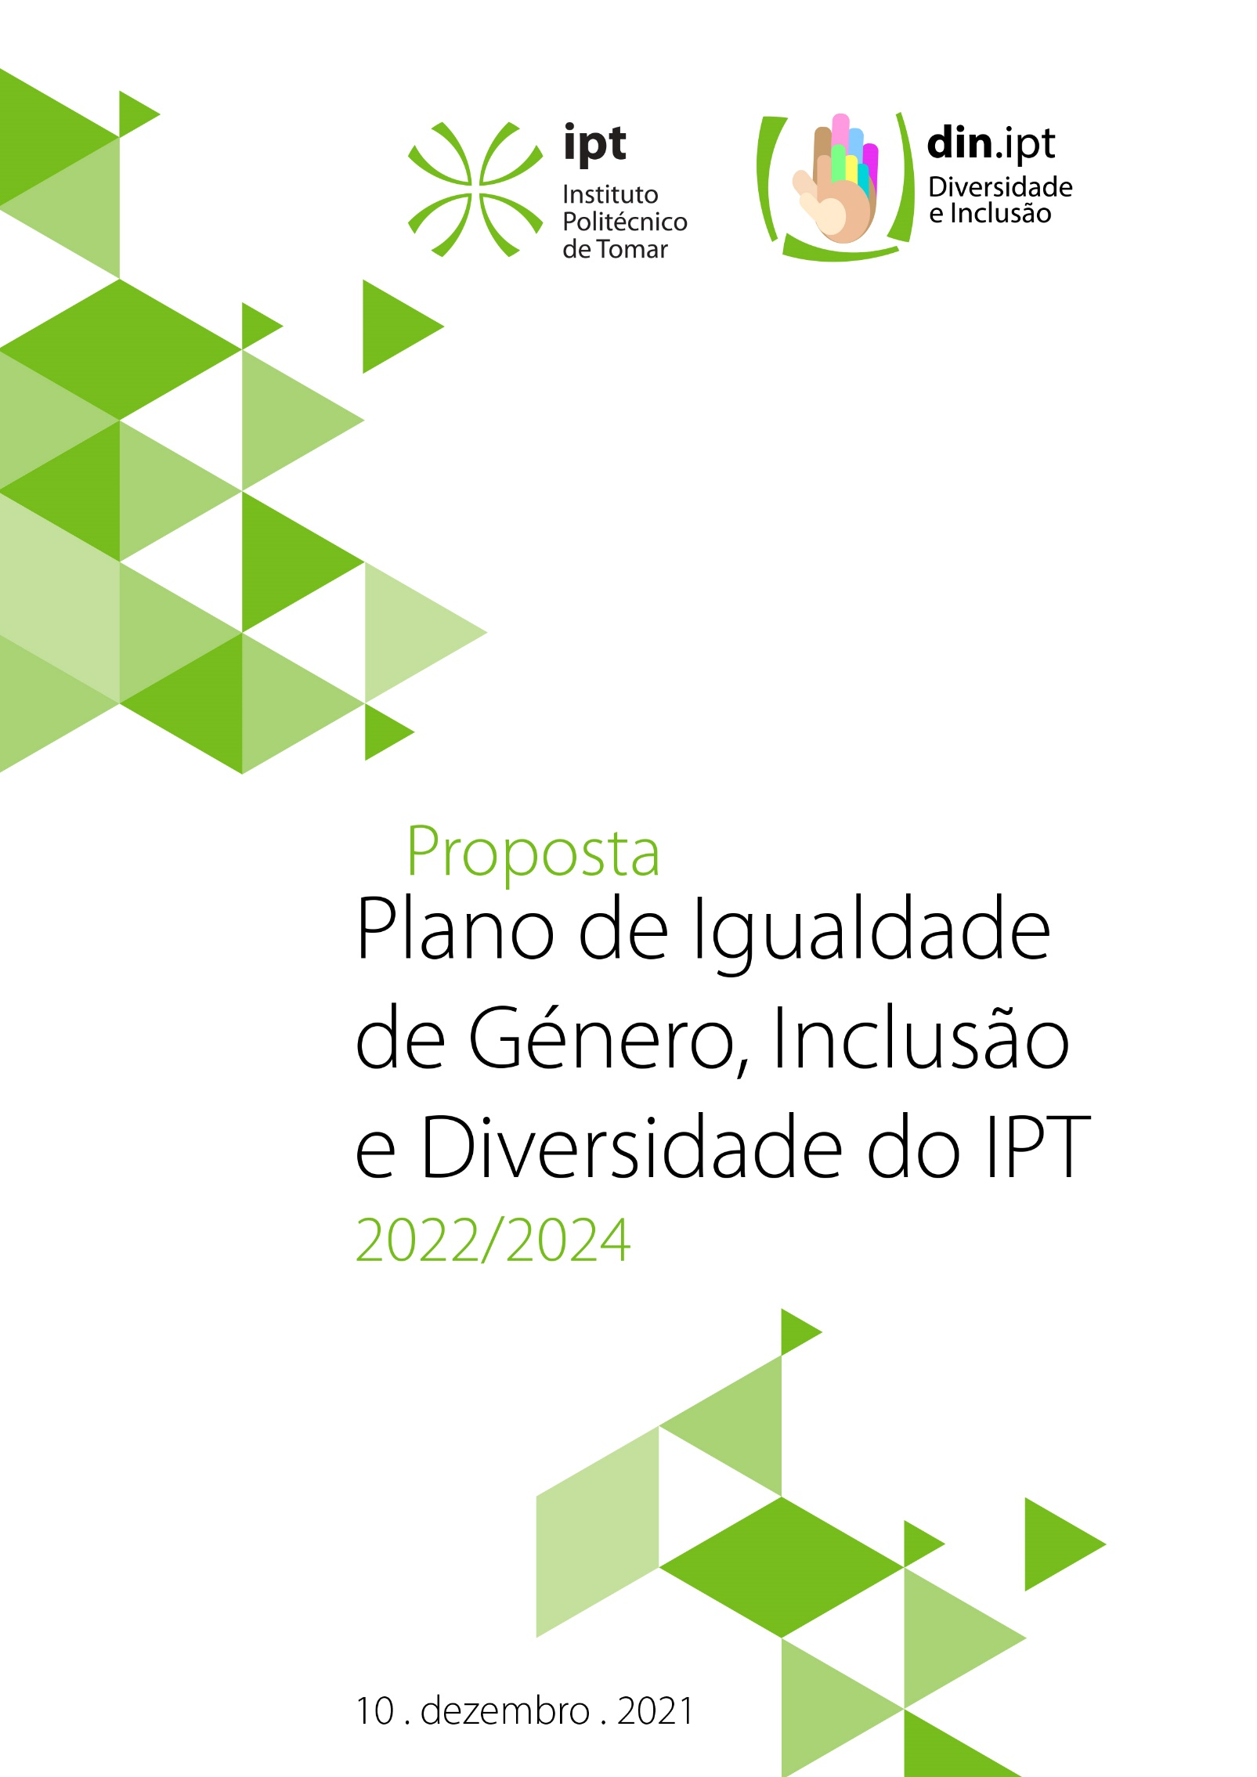
Proposal
Action Plan for Gender
Equality, Inclusion
and Diversity of the
Instituto Politécnico de Tomar
2022/24

Title
Team
IPT Action Plan for Gender Equality, Inclusion and Diversity
2021

Ana Cristina Becerra Nata dos Santos
José Casimiro Nunes Pereira
Natércia Maria Ferreira dos Santos
Paula Alexandra da Cruz Silva Pina de Almeida
Rita Ribeiro de Carvalho Ferreira Anastácio
Rosa Maria Ramos Nico
Sílvia Paula Rosa da Silva

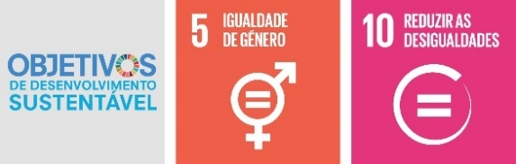

Table of Contents
Message from the President 5
Introduction 6
Background 8
Methodology 13
Internal survey: analysis and diagnostic 15
Policies and practices related to gender equality 15
Governing bodies 15
Academic/Research Staff 17
Technical Staff (employees/non-teaching staff) 17
Work-Life balance 18
Sexism, moobing and sexual and moral harassment 19
Action Plan 20
Priority Area 1 - Governance 20
Priority Area 2 - Internal and external communication 21
Priority Area 3 - Gender, education and research 21
Priority Area 4 – Harassment, sexist attitudes and violence 21
Priority Area 5 – Diversity and inclusion 21
Priority Area 6 – Balance between professional life and personal/family life 21
Final Remark 31

Message from the President
The Instituto Politécnico de Tomar (IPT) incorporates in its strategic framework a policy of inclusion independent of gender, ethnicity or religion and in accordance with the Sustainable Development Goals set by the United Nations Organisation. This understanding aims at the quality and excellence of all the activities we develop and in which we participate. The construction of a more tolerant, diverse and inclusive society must be, more than a goal, a reality examined down to the smallest detail.
The "IPT Gender Equality, Inclusion and Diversity Action Plan" was developed based on the methodologies recommended in the GEAR tool (Gender Equality in Academia and Research) and in the SAGE Wheel Toolkit2. It was developed by a multidisciplinary team based on diagnostic of official statistical data and surveys done among IPT community. This information gave rise to a set of objectives, responsible actions, indicators and goals to be achieved in the next triennium. I am sure that the whole academic community and each of us is sensitive and will take care to achieve these important goals in the fulfilment of the plan and of our mission, of "(...) access to knowledge for the benefit of people and society, through research, teaching and cooperation in a project of holistic development of the individual (...)".

Instituto Politécnico de Tomar, 31 January 2022
The President

Introduction
This Gender Equality, Diversity and Inclusion Plan is designed to implement and develop internal policies and practices that promote equal opportunities, diversity and inclusion in the IPT community, actively contributing to the achievement of sustainable development goals that act directly on this cause, specifically SDG 5 (gender equality) and SDG 10 (reduce inequalities).
Diversity must be understood as the recognition, respect and appreciation of the difference(s) among people, including in particular differences related to sex, gender identity, ethnicity, religion, territory of origin, culture, language, ancestry, age, political, sexual, ideological or social orientation, marital status, family situation, economic situation, health status, disability, personal style and education.
Inclusion must be a process that aims, through the abolition of barriers, at effective equal opportunities, education support and decent employment for all.
The IPT thus expects the diversity and inclusion policies to be developed will recognise, understand and value what unites us and what makes us different as a potential source of innovation, problem-solving, focus on the recipient, creativity and employee involvement.
The IPT also intends to assume the following institutional commitments, which are part of the Portuguese Charter for Diversity subscribed by our Institute, and also the recommendations included in the SAGE (Systemic Action for Gender Equality) Charter of Principles for gender equality:
- Incorporate equality and diversity in IPT's strategic documents;
- Encourage gender balance both at the technical or teaching career level, and at the level of institutional governance and decision-making positions;
- implement Human Resource Management practices based on the principles of diversity and inclusion, namely equal treatment and opportunities in the recruitment and selection process, training and professional development, performance appraisal, career progression and remuneration.
- Promote gender equality in research and funding opportunities;
- Ensure fairness and gender balance in evaluation panels for grants and institutional and research projects;
- Ensure the widespread adoption of best practices and awareness for gender equality in IPT's daily activities;
- Promote policies that take the family and work-life balance into consideration and that encourage the development of IPT's employees according to their needs and characteristics;
- Promote opportunities for reflection, learning and development of practices that promote Diversity both internally and externally;
- Share knowledge about gender equality and diversity in the various dimensions of the IPT and incorporate gender equality and diversity in the training of academics, researchers and support staff;
- Incorporate gender-sensitive practices, processes and procedures, removing barriers to equal participation of all genders in research and decision-making;
- Combat all forms of sexual and moral harassment at IPT.

With this plan, IPT not only commits to the Sustainable Development Goals, but also seeks to build a more sustainable and inclusive future through the actions proposed in this plan.

Background
Equality between women and men, or gender equality, means equal rights and freedoms as well as equal opportunities to participate, recognise and value women and men in all areas of society: political, economic, professional, personal and family.
This is established in various national, European and international laws and guidelines which regulate their integration into the various spheres of society, in order to ensure the legal protection of women and men and access to equal opportunities for all.
At national level, the promotion of equality between women and men is broadly grounded in the Constitution of the Portuguese Republic being recognised as one of the fundamental tasks of the State (art. 9). According to art. 13 on the principle of equality, all citizens have the same social dignity and are equal before the law. No one shall be privileged, favoured, prejudiced, deprived of any right or exempted from any duty because of ancestry, sex, race, language, territory of origin, religion, political or ideological beliefs, education, economic situation, social condition or sexual orientation. Other articles underpin the promotion of equality in our Constitution: Article 26 (Other personal rights), Article 36 (Family, marriage and filiation), Article 47 (Freedom of choice of profession and access to public service), Article 48 (Participation in public life), Article 49 (Right to vote), Article 58 (Right to work), Article 59 (Workers' rights); Article 67 (Family), Article 68 (Paternity and maternity), Article 74 (Education) and Article 109 (Political participation of citizens).
The National Strategy for Equality and Non-Discrimination 2018-2030 established by Resolution of the Council of Ministers No. 61/2018 and coordinated by the Commission for Citizenship and Gender Equality (CIG) advocates the elimination of stereotypes in three action plans - Action Plan for Equality between men and women, Action Plan for the Prevention and Reduction of Domestic Violence and Action Plan to Tackle Discrimination on the grounds of sexual orientation, gender identity and expression and sexual characteristics.
At the international level, the promotion of gender equality has been enshrined in benchmark documents which we will refer to in chronological order.
The Convention on the Elimination of All Forms of Discrimination against Women (1979) approved by the UN Assembly is a key instrument that reinforces the principle of equality between women and men. Portugal ratified this Convention in 1980. The CEDAW Convention is one of the major human rights treaties and is often referred to as the Magna Carta of Women's Rights or the Charter of Women's Human Rights.
The UN International Conference on Human Rights (1993) acknowledges that "The human rights of women and the girl-child are an inalienable, integral and indivisible part of universal human rights" (Vienna Declaration and Programme of Action, 1993, para. 18).
The UN Fourth World Conference on Women (1995) - Beijing Platform for Action - established a set of resolutions in 12 areas for action such as employment, health, education, security, migration, violence against women, prostitution, development, environment, among others, which called on the States to integrate gender equality in the design, implementation and evaluation of all policies and actions in the so-called gender mainstreaming strategy. The UN adopted the 2030 Agenda and sets out the 17 Sustainable Development Goals (SDGs). The gender dimension is considered to be crosscutting throughout the Agenda and constitutes the 5th SDG "Achieve gender equality and the empowerment of all women and girls" (UN, 2015).
Equality between women and men is also one of the European Union's goals. Indeed, since 1957 the European treaties have enshrined the principle of equality between women and men in all areas, including employment, work, pay (Articles 153 and 157 TFEU) combating all forms of discrimination including on grounds of gender (Article 19 TFEU), combating human trafficking, in particular women and children (Articles 79 and 83 TFEU) and eradicating violence against women (Article 168 TFEU).
The Treaty of Amsterdam (1997) reinforces the principle of non-discrimination acknowledging in Article 3 equality between women and men as one of the government’s tasks. In article 13 the Commission is given the right to take initiatives with a view to combating all forms of negative discrimination, particularly those based on sex, race or ethnic origin, religion or beliefs, disabilities, age or sexual orientation and, on the other hand, to encourage the implementation of positive action measures to create opportunities for workers who are disadvantaged for cultural or social reasons or for reasons of prejudice or tradition.
The European Charter of Fundamental Rights of the European Union also includes the principle of equality between women and men. Article 23 provides that "Equality between men and women must be ensured in all areas including employment, work and remuneration" but also that "The principle of equality shall not prevent the maintenance or adoption of measures providing for specific advantages in favour of the under-represented sex". Article 23 provides for the right to reconcile family and professional life. Another important European benchmark is the European Pact for Gender Equality endorsed by the Brussels European Council in 2006. There are also several European regulations, directives, decisions, recommendations and resolutions designed to promote equal opportunities between women and men and the reconciliation of professional and personal life.
Gender equality promotion is currently understood not only as a human rights issue, but also as an issue of peace, social justice and as a key sustainable development principle.
In this sense, governments and state bodies as well as all employees in public service have an obligation to work actively to promote equality between women and men. The promotion of equality should be taken into consideration in all aspects of political and public decision-making.
According to the European Commission, although on average in the EU women achieve higher levels of education than men, there are still gaps in some scientific fields of study which often allow access to better paid jobs. If women access these jobs, it will boost the economy, improve competition and productivity. However, the percentage of women in science, engineering, manufacturing, construction and ICT courses is still very low. There are still professions that tend to be female-dominated and others that tend to be male-dominated. It is necessary to encourage women to choose careers in male-dominated areas and to encourage men to choose careers in female-dominated areas that lack qualified workers.
Although the number of women with higher education qualifications is higher than that of men, women are still underrepresented in decision-making positions in higher education. With regard to the presence of women in the research sector, there have been positive developments, although significant inequalities still exist.
The growing participation of women in the labour market has not been accompanied by a corresponding growth in men's participation in family life. Women continue to be primarily responsible for carrying out domestic tasks and providing care for the family and there is a difference in the participation and use of time between women and men with regard to family life. This will contribute to a worsening of the living conditions of female workers who will see an exponential increase in the difficulties in reconciling their personal and professional lives.
With regard to paid work, women still occupy an unequal position, namely due to the difficulty in time management which stems from the social demands imposed on them in caring for the family.
In the pursuit of their careers in higher education, women continue to be faced with more obstacles than men due to the demands of family support that still fall mainly on them, making it more demanding for them to reconcile family and professional life.
It should be noted that it is women who make most use of the instruments available for reconciling family and professional life such as reduced working hours, career breaks and parental leave.
Although in recent years inequalities have been decreasing, there is still a long way to go to make gender equality a reality. The promotion of gender equality is a responsibility of the Public Administration. As such, in our opinion, Higher Education should play an essential role in the elimination and/or minimisation of these inequalities, raising awareness and educating for these issues and promoting gender equality in its community. That is the commitment we make with this equality plan of the IPT.

Methodology
The Equality plan of IPT was built with reference to the GEAR tool (Gender Equality in Academia and Research) , the SAGE Wheel Toolkit and the steps established therein for the preparation of equality plans in higher education institutions.
Firstly, a bibliographic review of national, European and international legislation and policies on gender equality and non-discrimination was carried out, more precisely those specific to the areas of research and/or higher education.
Then, in order to understand the reality in the IPT regarding equal opportunities for the different genders, an internal survey was carried out to determine which measures should be implemented according to the typology and context of the IPT and aligned with the legislation and national, European and international policies.
The internal survey consisted of the following steps and the application of the following diagnostic tools:
1.ª Etapa: Foram analisados dados desagregados por sexo sobre docentes, funcionários/as não-docentes e estudantes, respeitantes aos últimos 3 anos (2018, 2019, 2020), tais como:
Stage 1: Gender disaggregated data on teaching, non-teaching staff and students were analysed for the last 3 years (2018, 2019, 2020) such as:
- Distribution of governing bodies according to gender;
- Number of employees, non-teaching and teaching staff by professional category, type of contract and by gender;
- Composition of the academic and research staff by gender;
- Recruitment and termination of service of employees, technical and teaching staff by gender;
- Number and type of leave taken by employees, technical and teaching staff by professional category and by gender;
- Number of parental leave taken by c employees, technical and teaching staff and the respective return by professional category and gender;
- External funding, research scholarships and success rates by gender;
- Number of students by gender in each course.

Stage 2: Through a good practice survey, data was collected to identify existing measures to promote gender equality, namely with regard to: institutional governance, knowledge production, career progression and work-life balance.
Stage 3: Data collection and analysis through an online survey addressed to non-teaching staff and another to teaching staff, which aimed to analyse the current employment situation, career progression, work/life balance, level of satisfaction with the work environment, mobbing and harassment.
Subsequently, based on the data collected during the internal consultation and its analysis (section 4), an action plan was prepared (section 5). The Priority Areas and the goals to be achieved were set out, as well as the activities to be developed, respective scheduling, monitoring and expected impacts.

Internal Survey: analysis and diagnostic
Policies and practices related to gender equality
The diagnostic carried out, namely through the good practice survey, revealed that there are no references to gender equality in the IPT's Strategic Plan and Mission. However, IPT’s values include the commitment to the principle of equal opportunities. There is also no equality policy. It was found that little attention is given to gender issues in the language and logos of IPT's official documents and there is no inclusive language handbook.

Governing bodies
The data disaggregated by gender for the last three years (2018, 2019, 2020) allowed us to conclude that governing bodies were mostly occupied by men. However, there is a decreasing trend in the number of men in these positions in the triennium under review where the number of men was equal to 27, 26 and 25, respectively in 2018, 2019 and 2020, and in the case of women, an opposite increasing trend, more precisely 10 women in 2018, 14 in 2019 and 15 in 2020.
With regard to the composition of the Board, in the three years under review, the positions of President and Vice-President were always held by men and in 2018 no woman held a position in the Board, a situation that was reversed in the years 2019 and 2020 with the appointment of two women as senior directors. In 2018, the Board was composed of 3 male and 2 female members.
Regarding the Management Committee, the body that conducts the institution’s administrative, accounting and financial management as well as human resources management, it has always been composed only of men throughout the three years under review. In 2018 the Management Committee was composed of 3 elements and in 2019 and 2020 by 4 elements.
The General Council is made up of 21 members. Of these 21 members, 14 are men and 7 are women. It was found that there is a decreasing trend in the number of men in the three years under review, i.e. 16, 15 and 14, respectively, in 2018, 2019 and 2020. Conversely, there was an increasing trend in the number of women, namely 5, 6 and 7, in 2018, 2019 and 2020, respectively, although the number of men is still frankly higher (about 67%).
In what concerns the management board of the three IPT schools, two men were in charge of the School of Technology and School of Management at Tomar and one woman in the case of the School of Technology at Abrantes.
Regarding the three middle management positions in the IPT, they were always occupied by women and concern the Academic Services Division, the Human Resources Division and the Financial and Property Services Division.
On the other hand, the position of Student Ombudsman during the three-year period under review was always occupied by a man.
The Academic Council, a consultative body of the IPT, with competences within the academic life in general and in the technical-scientific and pedagogical scope in particular also has a higher male representativeness throughout the 2018-2020 triennium. Although in the last two years there has been a decrease in the number of male representatives and an increase in the number of female representatives, the number of male representatives is still much higher, 68% of all members.
IPT's chairs of academic departments are mostly occupied by men i.e. 71.4% of the heads of department are men. The same happens with programme directors of which 61.9% are male.

Academic/Research Staff
With regard to the distribution of faculty members by gender, the number of male members was always higher throughout the triennium under review, occupying 64.13%, 64.16% and 63.03% of all members in 2018, 2019 and 2020 respectively.
In the analysis carried out by professional category, the discrepancy is greater the higher the category. There is a high masculinisation in the Full Professor position, with more than 70% of male academics occupying this category. With regard to the Associate Professor category, men are also in a higher position, since more than 61% of the teaching staff were male in this category. Finally, in the Assistant Professor category, around 65% were male, with men also being numerically superior.
With regard to master's degree supervisors, most of the supervisors are male (69%) as well as the arguers (70%) and the panel chairpersons (61.5%). Internship/undergraduate/other supervisors are also mostly male (60%) as well as the examiners (63.2%) and the panel chairpersons (75%).

Technical Career Staff (non-teaching staff)
Contrary to what happened with the teaching staff, the analysis of the distribution of IPT non-teaching staff according to gender showed a clear prevalence of women, on average above 70%. By professional category, the difference between genders is smaller in the highest position of Senior Technician, with approximately 65% female.
The exception is found in the IT career where the number of male employees is higher at about 78%.
From the data collected about IPT's students a prevalence although not very significant (56,8%) of male students may be observed. Nevertheless, in the distribution per academic level there is a higher number of female students in the Master degree courses. On the contrary, in the Engineering and Technology courses there is a clear predominance of male students and in some degree programmes, namely Electrical and Computer Engineering, Computer Engineering, Chemical and Biochemical Engineering, Mechanical Engineering and Multimedia Technologies, the difference is quite high, with percentages above 80% and in some cases exceeding 90%. There are only a few exceptions, as in the case of Conservation and Restoration, Design and Graphic Arts Technology and Chemical Technology where the number of female students is higher.

Work-life balance
The IPT is aligned with national legislation regarding policies for reconciling professional, personal and family life, namely initial parental leave for mother and father, adoption, sabbatical, caregiver and flexible working arrangements.
With regard to the enjoyment of some type of leave that facilitates the balance between professional and personal life of teaching staff, based on the data collected it was possible to see that in two of the three years under review (2018 and 2020) there was equality in both genders. In the year 2019, there is a greater number of leaves used by the female gender (75%). With regard to non-teaching staff, the majority of leaves were taken by women, but there is a downward trend in the period under review. In 2018, all leave was taken by women, in 2019 leave taken by women represented 83% of the total and in 2020, only 60% was taken by women.
Parental leave, shared parental leave and, in a greater number of cases, flexible working hours were taken, namely by non-teaching staff.
In the questionnaire administered to the teaching staff, it can be seen that the majority of them regularly work more than the planned working hours (69%). The reasons most often given were: class preparation and participation in international projects; daytime and post-labour teaching hours.
Based on the answers received, it can be seen that not having classes after 6 p.m. would allow teachers to achieve a better balance between their personal, family and professional life. Most of the teachers would like to have more time to dedicate to research.
It was also possible to observe that the IPT teaching and non-teaching staff are unaware of any support services or benefits available for employees with responsibilities in caring for dependents (ascendants or descendants).

Sexism, mobbing and sexual and moral harassment
The survey of good practice showed that there is no code of conduct to prevent and combat sexual and moral harassment at the IPT.
The questionnaires carried out with teaching and non-teaching staff showed that there are, although in a reduced number, sexist attitudes and behaviours, namely teasing, jokes, comments or sexual/sexist questions.

Action Plan
The IPT’s Gender Equality, Inclusion and Diversity Plan is organised into six priority areas of action for which strategic objectives and actions have been set out. For each action some elements were identified such as the year of implementation, the people in charge as well as the monitoring indicators and respective targets.

This Plan sets out six Priority Areas:
1. Governance
2. Internal and external communication
3. Gender, teaching and research
4. Harassment, sexist attitudes and discrimination
5. Diversity and Inclusion
6. Work-life balance.

For each Priority Area, the following strategic goals have been identified:

Priority Area 1 - Governance
Goal: Incorporate the gender dimension in IPT's organisational culture.
Action 1: Draw up a policy proposal on gender equality and diversity at IPT
Action 2: Engage to promote equality between women and men in the IPT's strategic plan
Action 3. Characterise the IPT community by gender and disability
Action 4. Create an IPT Focus Group (FG) to diagnose the vision of workers on gender equality, gender stereotypes, articulation of professional, family and personal life, moral and sexual harassment at work.
Action 5. Implement training actions for workers aimed at gender equality and non-discrimination issues.

Priority Area 2 - Internal and external communication
Goal: Raise awareness in the IPT and in the wider community of the principles of gender equality.

Priority Area 3 – Gender, education and research
Goals:
- To combat segregation and promote the balanced representation of women and men in teaching and research activities.
- To sensitise female and male students to the need to opt for scientific fields of study where they are underrepresented.
- To sensitise the international community to the importance of gender equality in teaching and research

Priority Area 4 – Harassment, sexist attitudes and violence

Goal: Combat harassment and violence.

Priority Area 5 – Diversity and Inclusion
Goal: Promote diversity and an inclusive environment and prevent discrimination.

Priority Area 6 – Balance between professional life and personal/family life
Goal: Improve the reconciliation between work and personal and family life.
In order to monitor the Plan and evaluate the achievement of the goals, a set of indicators and respective targets were set out for each action.
After the implementation of the plan, it requires monitoring, which will allow an annual assessment of the degree of implementation of the actions and analysis of the results achieved by measuring the indicators and respective targets. Annual reports to be publicly disseminated are provided for in the Plan, thus ensuring the institution’s commitment to the successful implementation of the plan.
The following table presents the synthesis of the Action Plan and the respective monitoring as well as the responsible services or groups of the IPT community:

CIS - Computer and Systems Centre;
DRH - Human Resources Division.
DSA - Academic Services Division;
GCRP - Communication and Public Relations Office;
GDI - Diversity and Inclusion Group
GJ - Legal Office;
GRI - International Relations Office;
GTNorma - Work Group for Reconciliation of Professional, Personal and Family Life;

Plan for Gender Equality, Inclusion and Diversity - IPT - 2022-2024
Priority Area 1 – Governance
Goals | Actions | Chair:  Staff | Indicator | Implementation |  |  | Targets
 |  |  |  | 2022 | 2023 | 2024
To incorporate the gender perspective in IPT's organizational culture | 1. Draft a proposal for a gender quality, inclusion and diversity policy at IPT | GDI; The Board; GCRP | Drafting, posting of gender equality and diversity policy. | x |  |  | Policy posted until the end of 2022
 | 2. Commit to promoting equality between women and men in the IPT's strategic plan | GDI; The Board | Commitment to equality in strategic plan. |  |  | x | Strategic plan with commitment to M/H equality by the end of 2024
 | 3. Characterise the IPT community by gender and disability | GDI; DRH; DSA, CIS | Annual Report on the GDI web page. | x | x | x | Annual report available until the end of February of the following year
 | 4. Create an IPT Focus Group (FG) to diagnose the vision of workers on gender equality, gender stereotypes, articulation of professional, family and personal life, moral and sexual harassment at work. | GDI; GCRP | Focus Group;  Diagnostic Report | x | x | x | Focus group by the end of 2022;  Diagnostic report by the end of February of the following year
 | 5. Training actions for employees focused on the topics of gender equality and non-discrimination. | GDI; DRH | No. of training actions carried out;  No. of participants;  No. of surveys filled out by participants;  Evaluation report. | x | x | x | 1 training session per year.
Priority Area 1 – Governance (continued)
Goals | Actions | Chair:  Staff | Indicator | Implementation |  |  | Targets
 |  |  |  | 2022 | 2023 | 2024
To incorporate the gender perspective in IPT's organizational culture | 6. Include information about the existence of the Diversity and Inclusion Group in the welcoming guides for new employees and students. | GDI; GCRP | Text to be included in the guide for welcoming new employees;  Text to be included in the guide for welcoming new students. | x |  |  | 2 texts produced to be included in the scripts; Information about the existence of the Diversity and Inclusion Group until the end of 2022
 | 7. Plan monitoring and evaluation after implementation | GDI | Annual schedule with the measures to be carried out monthly;  Evaluation report. | x | x | x | Biannual monitoring report by the end of July and annual evaluation report by the end of February of the following year.
 | 8. Disclosure of the annual evaluation report of IPT's Plan for Gender Equality; | GDI | Presentation of the annual evaluation report;  Satisfaction survey and collection of contributions. |  | x | x | Submission of the annual evaluation report of the IPT's Plan for Gender Equality by the end of March of the following year

Priority Area 2 – Internal and external communication, image and language
Goals | Actions | Chair:  Staff | Indicator | Implementation |  |  | Targets
 |  |  |  | 2022 | 2023 | 2024
Raise the awareness of IPT and the wider community to the principles of gender equality | 9. Creating an inclusive, gender-sensitive language guide for IPT's internal and external communication; | GDI; GCRP | Guide of rules for an inclusive language accessible to the entire IPT community. |  | x |  | Guide available until the end of 2023
 | 10. Design of a web page and a logo to allow the dissemination and promotion of the themes of gender equality and inclusion; | GDI; CIS; GCRP | Web page and logo of the Diversity and Inclusion Group. | x |  |  | Web page and logo by the end of January 2022
 | 11. Dissemination of IPT's plan for gender equality, inclusion and diversity and the respective actions; | GDI | Definition and implementation of communication plan (website and social networks). | x | x | x | Disclosure of the plan and actions by the end of January of each year
 | 12. Holding themed events to raise awareness of gender equality and inclusion accessible to the entire academic community. | GDI; GCRP | No. of events held;  No. of participants;  No. of surveys filled out by participants;  No. of survey responses. | x | x | x | 1 thematic event per year

Priority Area 3 – Gender, education and research
Goals | Actions | Chair:  Staff | Indicator | Implementation |  |  | Targets
 |  |  |  | 2022 | 2023 | 2024
Combat segregation by promoting balanced representation of women and men in teaching and research faculty | 13. Campaigns to encourage female candidates for scientific career advancement | GDI; GCRP | No. of campaigns carried out;  No. of surveys filled out by participants;  No. of survey responses. | x | x | x | 1 campaign per year
To promote the choice by students of both genders of scientific areas/studies where one gender is under-represented | 14. Promotion of thematic events to increase demand and reduce the discrepancy | GDI; GCRP | No. of events held;  No. of participants;  No. of surveys filled out by participants;  No. of survey responses. | x | x | x | Reduce the gender division in science, technology and engineering by deconstructing stereotypes about professions in these areas by x%.
Raise awareness in the international community about the importance of gender equality in education and research | 15. Organisation of International event | GRI; GDI; GCRP | Event;  Number of participants;  No. of surveys filled out by participants;  No. of survey responses. |  | x |  | 1 thematic event per triennium

Priority Area 4 – Harassment, sexist attitudes and violence
Goals | Actions | Chair:  Staff | Indicator | Implementation |  |  | Targets
 |  |  |  | 2022 | 2023 | 2024
Promote an inclusive environment, prevent discrimination, and combat harassment and violence | 16. Development of a Code of Good Conduct for the Prevention and Combating of Harassment at Work | GDI; DRH; GJ | Code of Conduct Guide |  | x |  | Code of Conduct available on the GDI website by the end of 2023
 | 17. Disclosure of the whistleblowing procedures according to the legislation in force. | GDI; GCRP | No. of complaints by gender. |  |  | x | rate of complaints handled by the end of 2024
 | 18. Include in the workers' training plan actions focused on the theme of harassment and dating violence | GDI; DRH | No. of training actions carried out;  No. of participants;  No. of surveys filled out by participants;  Evaluation report. | x | x | x | 1 training session per year
 | 19. Holding thematic events to raise awareness about dating harassment and violence | GDI; GCRP | No. of training actions carried out;  No. of participants;  No. of surveys filled out by participants;  Evaluation report. | x | x | x | 1 event per year

Priority Area 5 – Diversity and inclusion
Goals | Actions | Chair:  Staff | Indicator | Implementation |  |  |  | Targets
 |  |  |  | 2022 | 2023 |  | 2024
Promote diversity, inclusive environments and prevent discrimination | 20. Applying for the diversity seal | GDI | Application submission. |  |  |  | x | Diversity Stamp by 2024
 | 21. Creation of flyer and videos allusive to the topic of non-discrimination and inclusion | GDI; GCRP | No. of flyers distributed and disseminated;  No. of videos | x |  | x | x | One flyer per year  One video per year
 | 22. Identification of possible movement obstacles on campus for people with disabilities | GDI | Report |  |  |  | x | 1 report available on the IDG website by the end of 2024
 | 23.Organization of thematic events and other initiatives that promote diversity and inclusion, addressed to national and international students and mobile students | GDI; GRI; GCRP | No. of events held;  No. of participants;  No. of surveys filled out by participants;  No. of survey responses. | x |  | x | x | 1 thematic event per year
 | 24. Creation of an online channel for collecting suggestions and identifying possible discriminatory problems in its various aspects | GDI; GCRP | Online suggestion channel (website). | x |  |  |  | 1 online channel by the end of 2022
Priority Area 6 – Balancing work life and personal and family life
Goals | Actions | Chair:  Staff | Indicator | Implementation |  |  |  | Targets
 |  |  |  | 2022 | 2023 |  | 2024
Improve the reconciliation between professional, personal and family life of staff (faculty members and technical staff) | 25. Contribute with suggestions for the revision of the internal regulation of the working hours of the teaching staff | GDI | Document containing recommendations. |  |  | x |  | 1 recommendation until the end of 2023
 | 26. Produce a recommendation for meetings to be scheduled during normal working hours and that mandatory professional training/updating courses be held at times compatible with work and family responsibilities | GDI | Document containing recommendations. |  |  | x |  | 1 recommendation until the end of 2023
 | 27. Carry out actions to disseminate information about the rights to work-family articulation existing in the law, appropriate to workers and students. | GDI | No. and type of initiatives  No. of participants  No. of surveys filled out by participants;  Evaluation report. | x |  | x | x | 1 dissemination action per year

Priority Area 6 – Balancing work life and personal and family life (continued)
Goals | Actions | Chair:  Staff | Indicator | Implementation |  |  |  | Targets
 |  |  |  | 2022 | 2023 |  | 2024
Improve the reconciliation between professional, personal and family life of employees (faculty members and technical staff) | 28. Implementation of the Reconciliation Management System (CMS) procedures NP-4522 - Reconciliation between professional, family and personal life. | GTNorma; GDI | Questionnaire for listening to relevant stakeholders;  No. of measures to be implemented;  Questionnaire to assess satisfaction. |  |  | x |  | 1 reconciliation management system by the end of 2023  Increase the level of satisfaction of relevant stakeholders by 40%
 | 29. Certification Reconciliation Management System - CMS) - NP-4552 - Management system for reconciliation between professional, family and personal life | GTNorma; GDI | Certified Management System for Conciliation between professional, family and personal life. |  |  | x |  | SGC d- IPT Certification - NP-4552 - until the end of 2023

Final remark
The IPT's Plan for Gender Equality, Inclusion and Diversity was drawn up by the Diversity and Inclusion Working Group and involved several services, already mentioned, as well as faculty, researchers and administrative and technical staff who collaborated in the preparation of the diagnostic and plan, directly or indirectly.
In order to involve the whole IPT Community, the plan proposal was publicly presented on December 10th 2021 - International Human Rights Day - and it was later made available for consultation and collection of contributions on the IPT website.
The IPT is committed to implement this action plan aiming at contributing to an effective gender equality, fight inequalities, promote inclusion and value differences in our Community within the next three years.
The IPT also intends to take small steps towards achieving the Sustainable Development Goals (SDGs) that act directly in this cause, more specifically SDG 5 (gender equality) and SDG 10 (reduce inequalities).
It is now up to the IPT community and to each one individually to understand the importance of this theme and contribute to promote gender equality, inclusion and diversity!
This Plan is intended to take the first steps in this direction.

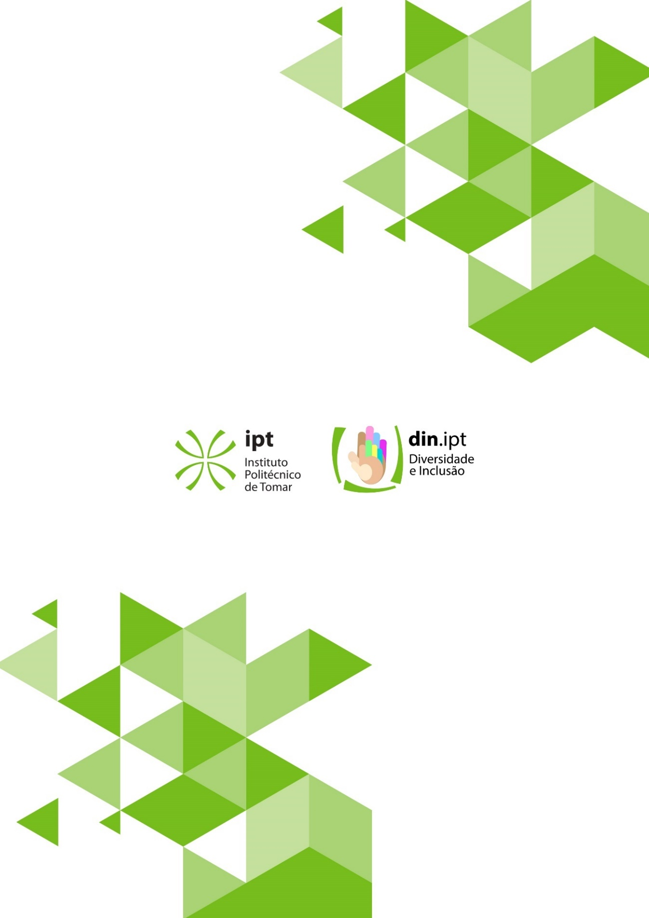

https://eige.europa.eu/gender-mainstreaming/toolkits/gear

